**CONTROL STRUCTURES (SWITCH CASE) AND**

**REPETITIVE STRUCTURES (FOR LOOP)**

**LAB # 4**



**Spring 2019**

**CSE102L Computer Programming Lab**

Submitted by: **SHAH RAZA**

Registration No. : **18PWCSE1658**

Class Section: **B**

“On my honor, as student of University of Engineering and Technology, I have neither given nor received unauthorized assistance on this academic work.”

Student Signature: ______________

Submitted to:

**Engr. Madiha Sher**

March 20, 2019

Department of Computer Systems Engineering

University of Engineering and Technology, Peshawar

## Objectives:

## To understand the programming knowledge using Decision Statement “switch”

* To understand the programming using for Loop

**TASK #1:**

Write a program to input two integer numbers and display the sum of even numbers between these two input numbers.

**Code:**

#include <iostream>

using namespace std;

int main()

{

int num1,num2,sum=0; //Variable declaration

cout << "Enter the First number: "; //Display message

cin>>num1; //Input num1

cout << "Enter the Second number: "; //Display message

cin>>num2; //Input num2

cout<<"The sum of even numbers between "<<num1<<" and "<<num2<<" is: "; //Display message

while(num1<=num2) //Loop repetition from num1 to num2

{

if(num1%2==0) //If number is even

{

sum+=num1; //Even numbers are added to sum

}

num1++; //Number incrementation

}

cout<<sum; //Display sum

return 0;

}

**Output (Compilation, Debugging and Testing):**

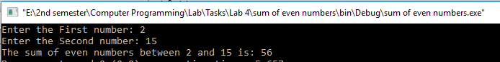

**TASK #2:**

Write a program to print all natural numbers in reverse (from n to 1).

**Code:**

#include <iostream>

using namespace std;

int main()

{

int n; //Variable Declaration

cout << "Enter the value of n: "; //Display message

cin>>n; //Input n

for(int i=1;i<=n;n--) //Loop repetition from n to i

{

cout<<n<<endl; //Display Number

}

return 0;

}

**Output (Compilation, Debugging and Testing):**

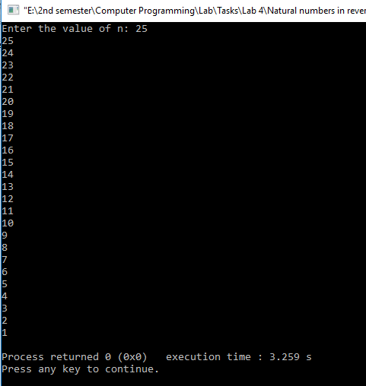

**TASK #3:**

Write a program that takes a number as input, checks it if it is between 1 and 25 (using switch) and if it is in valid range your program should output a line containing that number of adjacent asterisks. On invalid input number, the program should end.For example, if your program input is 7, it should print *******.

**Code:**

#include <iostream>

using namespace std;

int main()

{

int num,i=1; //Variable declaration

cout << "Enter a number: "; //Display message

cin>>num; //Input num

switch(num>=1 && num<=25) //Check whether num is between 1 and 25 or not

{

case 1: //num is between 1 and 25

while(i<=num) //Loop repetition from i to num

{

cout<<" * "; //Display asterisks

i++; //Increment i

}

break;

case 0: //Num is not between 1 and 25

cout<<"Please enter a number between 1 and 25"; //Display message

}

return 0;

}

**Output (Compilation, Debugging and Testing):**

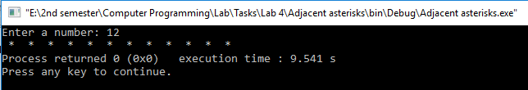

**TASK #4:**

Write a program to create Simple Calculator using switch case.

**Code:**

#include <iostream>

using namespace std;

int main()

{

//Variable declaration

float num1,num2,result;

char OP;

cout << "Enter Operand1: "; //Display message

cin>>num1; //Input num1

cout<<"Enter Operator: "; //Display message

cin>>OP; //Input num1

cout<<"Enter Operand2: "; //Display message

cin>>num2; //Input num1

switch(OP) //Transfer control on the basis of the value of OP

{

case '+': //If OP is +

cout<<"Result: "<<num1+num2; //Display sum

break;

case '-': //If OP is -

cout<<"Result: "<<num1-num2; //Display difference

break;

case '*': //If OP is *

cout<<"Result: "<<num1*num2; //Display Product

break;

case '/': //If OP is /

cout<<"Result: "<<num1/num2; //Display Division

break;

default: //If OP is none of the above

cout<<"Invalid Operator Used"; //Display message

}

return 0;

}

**Output (Compilation, Debugging and Testing):**

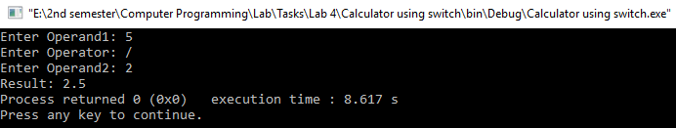

**TASK #5:**

Write a program to find Factorial of a number.

**Code:**

#include <iostream>

using namespace std;

int main()

{

int num,i=1,factorial=1; //Variable declaration

cout << "Enter a number: "; //Display message

cin>>num; //Input num

while(i<=num) //Loop repetition from i to num

{

factorial*=i; //Calculating factorial

i++; //Increment i

}

cout<<"Factorial of "<<num<<" is: "<<factorial; //Display factorial

return 0;

}

**Output (Compilation, Debugging and Testing):**

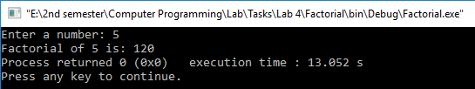

**TASK #6:**

Write a program to print multiplication table of any number.

**Code:**

#include <iostream>

using namespace std;

int main()

{

int num,i=1; //Variable declaration

cout << "Enter a number: "; //Display message

cin>>num; //Input num

cout<<" Multiplication Table: \n";

while(i<=10) //Repeat 10 times

{

cout<<num<<" X "<<i<<" = "<<num*i<<endl; //Multiplication Table

i++; //Increment i

}

return 0;

}

**Output (Compilation, Debugging and Testing):**

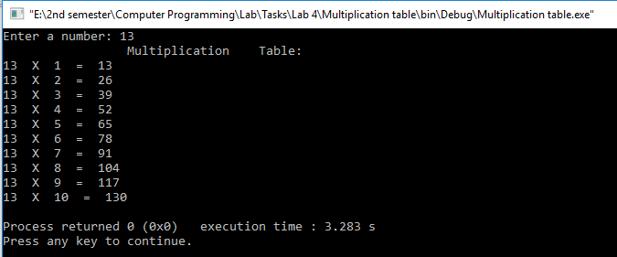

**TASK #7:**

Write a program to print all ASCII character with their values.

**Code:**

#include <iostream>

using namespace std;

int main()

{

for(int i=0;i<=255;i++) //Loop runs 256 times

{

char ch= i; //Changing code to character

cout<<i<<": "<<ch<<endl; //Display code with respective character

}

return 0;

}

**Output (Compilation, Debugging and Testing):**

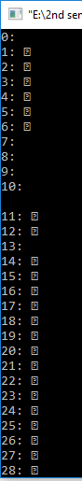 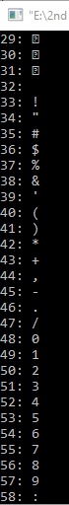       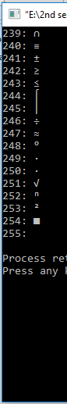

**TASK #8:**

Write a program that takes the base and exponent as input and display the result of power.

**Code:**

#include <iostream>

using namespace std;

int main()

{

int base,exp,result=1,i=1; //Variable declaration

cout << "Enter the value of Base: "; //Display message

cin>>base; //Input base

cout<<"Enter the value of Exponent: "; //Display message

cin>>exp; //Input exponent

while(i<=exp) //Loop repetition from i to exp

{

result*=base; //Calculation

i++; //Increment i

}

cout<<"The result is: "<<result; //Display result

return 0;

}

**Output (Compilation, Debugging and Testing):**

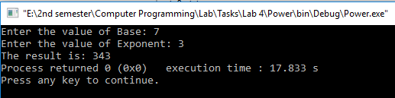

**TASK #9:**

Write a program to check if a number input by user is PRIME or not, range of input is 1 to 300.

**Code:**

#include <iostream>

using namespace std;

int main()

{

int num,i=2,test=0;//Variable declaration

cout << "Enter a number: "; //Display message

cin>>num; //Input num

if(num>=1 && num<=300) //If Number is between 1 and 300

{

while(i<=num) //Loop repetition from i to num

{

if(num%i==0)

{

test++;

}

i++;

}

switch(test) //Transfer of control based on the value of test

{

case 0 ... 1: //Prime Number

cout<<num<<" is a PRIME number"; //Display message

break;

default: //Composite Number

cout<<"This is not a prime number"; //Display message

}

}

else //Number is not between 1 and 300

cout<<"This number is not in the range(1-300)"; //Display message

return 0;

}

**Output (Compilation, Debugging and Testing):**

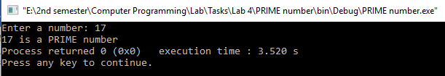

**TASK #10:**

Write a guessing game where the user has to guess a secret number. After every guess the program tells the user whether their number was too large or too small. At the end the number of tries needed should be printed.

**Code:**

#include <iostream>

using namespace std;

int main()

{

//Variable declaration

int num=rand();

int guess,counter=0;

cout << "Guess the number: "; //Display message

cin>>guess; //Input guess

while(guess!=num) //Repeat Loop if guess is not equal to num

{

counter++; //Increment counter

if(guess<num) //Guess is less than num

{

cout<<"Guess again with a higher number: "; //Display message

cin>>guess; //Input guess

}

else //Guess is greater than num

{

cout<<"Guess again with a lower number: "; //Display message

cin>>guess; //Input num

}

}

counter++; //Increment counter

cout<<"You Win\n"; //Display message

cout<<"Number of tries: "<<counter; //Display number of tries

return 0;

}

**Output (Compilation, Debugging and Testing):**

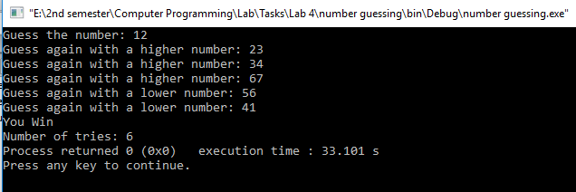

**TASK #11:**

Write a program to display Fibonacci series up to 200.Fibonacci series: 0, 1, 1, 2, 3, 5, 8, 13, ….

**Code:**

#include <iostream>

using namespace std;

int main()

{

int a=0,b=1; //Variable declaration

cout << "Fibonacci series up to 200: " << endl; //Display message

cout<<a<<" "; //Display a

cout<<b<<" "; //Display b

for (int c=a+b;c<=200;c=a+b)//Fibonacci Series up to 200

{

cout<<c<<" "; //Display c

a=b;

b=c;

}

return 0;

}

**Output (Compilation, Debugging and Testing):**

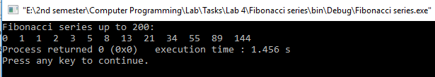

**TASK #12:**

Write a program to find GCD (greatest common divisor or HCF) and LCM (least common multiple) of two numbers.

**Code:**

#include <iostream>

using namespace std;

int main()

{

int num1,num2; //Variable declaration

cout << "Enter the First number: "; //Display message

cin>>num1; //Input num1

cout<<"Enter the Second number: "; //Display message

cin>>num2; //Input num2

int a=num1*num2;

while(num1!=num2) //Repeat Loop when num1 is not equal to num2

{

if(num1>num2) //num1 is greater than num2

{

num1=num1-num2;

}

if(num2>num1) //num2 is greater than num1

{

num2=num2-num1;

}

}

cout<<"HCF of these numbers is: "<<num1; //Display HCF

int LCM=a/num1; //Calculation for LCM

cout<<"\nLCM of these numbers is: "<<LCM; //Display LCM

return 0;

}

**Output (Compilation, Debugging and Testing):**

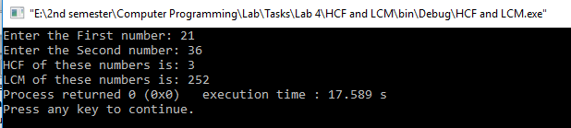

**TASK #13:**

Write a program that performs a survey tally on beverages. The program should prompt for the next person until a sentinel value of –1 is entered to terminate the program. Each person participating in the survey should choose their favorite beverage from the following list:

1. Coffee 2. Tea 3. Coke 4. Orange Juice

**Sample Run:**

Please input the favorite beverage of person #1: Choose 1, 2, 3, or 4 from the above menu or -1 to exit the program  
4  
Please input the favorite beverage of person #2: Choose 1, 2, 3, or 4 from the above menu or -1 to exit the program  
1  
Please input the favorite beverage of person #3: Choose 1, 2, 3, or 4 from the above menu or -1 to exit the program  
3  
Please input the favorite beverage of person #4: Choose 1, 2, 3, or 4 from the above menu or -1 to exit the program  
1  
Please input the favorite beverage of person #5: Choose 1, 2, 3, or 4 from the above menu or -1 to exit the program  
1  
Please input the favorite beverage of person #6: Choose 1, 2, 3, or 4 from the above menu or -1 to exit the program  
-1  
The total number of people surveyed is 5. The results are as follows:

Beverage Number of Votes  
*****************************************  
Coffee 3  
Tea 0  
Coke 1  
Orange Juice 1

**Code:**

#include <iostream>

using namespace std;

int main()

{

//Variable Declaration

int coffee=0,tea=0,coke=0,orange_juice=0;

int choice,i=0;

cout << "What is your favorite beverage: " << endl; //Display message

cout<<"(1) Coffee (2) Tea (3) Coke (4) Orange Juice\n\n"; //Display message

do

{

i++; //Increment i

cout<<"Please input the favorite beverage of person #"<<i<<": Choose 1, 2, 3, or 4 from the above menu or -1 to exit the program\n";

cin>>choice; //Input choice

switch(choice) //Transfer control based on value of choice

{

case 1: //choice is 1

coffee++; //Increment coffee

break;

case 2: //choice is 2

tea++; //Increment tea

break;

case 3: //choice is 3

coke++; //Increment coke

break;

case 4: //choice is 4

orange_juice++; //Increment orange_juice

break;

case -1: //choice is -1

break;

default: //choice is none of the above

cout<<"Invalid Entry\n";

}

}while(choice!=-1);

cout<<"The total number of people surveyed is "<<i-1; //Display no. of people

cout<<".The results are as follows: \n"; //Display message

cout<<"Beverage Number of Votes\n"; //Display message

cout<<"*****************************************"; //Display message

cout<<"\nCoffee "<<coffee;

cout<<"\nTea "<<tea;

cout<<"\nCoke "<<coke;

cout<<"\nOrange Juice "<<orange_juice;

return 0;

}

**Output (Compilation, Debugging and Testing):**

